**IPL DATABASE**

**DDL**

**Database Creation:-**

CREATE DATABASE "IPL database"

WITH

OWNER = postgres

ENCODING = 'UTF8'

LC_COLLATE = 'en-US'

LC_CTYPE = 'en-US'

LOCALE_PROVIDER = 'libc'

TABLESPACE = pg_default

CONNECTION LIMIT = -1

IS_TEMPLATE = False;

**Create ENUM types:-**

CREATE TYPE leadership_role_enum AS ENUM ('None', 'Captain', 'ViceCaptain');

CREATE TYPE staff_role_enum AS ENUM ('Head Coach', 'Batting Coach', 'Bowling Coach', 'Fielding Coach', 'Physio', 'Other');

**Creating Franchise Table:-**

CREATE TABLE Franchise (

franchise_id SERIAL PRIMARY KEY,

franchise_name VARCHAR(200) NOT NULL,

city VARCHAR(45) NOT NULL,

trophy_count INT DEFAULT 0

);

**Creating Player Table:-**

CREATE TABLE Player (

player_id SERIAL PRIMARY KEY,

player_name VARCHAR(200) NOT NULL,

role VARCHAR(100) NOT NULL,

contract_amount INT NOT NULL,

leadership_role leadership_role_enum DEFAULT 'None',

franchise_id INT,

FOREIGN KEY (franchise_id) REFERENCES Franchise(franchise_id) ON DELETE CASCADE

);

**Creating Owner Table:-**

CREATE TABLE Owner (

owner_id SERIAL PRIMARY KEY,

owner_name VARCHAR(200) NOT NULL,

group_name VARCHAR(200),

city VARCHAR(200),

franchise_id INT,

FOREIGN KEY (franchise_id) REFERENCES Franchise(franchise_id) ON DELETE CASCADE

);

**Creating Stadium Table:-**

CREATE TABLE Stadium (

stadium_id SERIAL PRIMARY KEY,

stadium_name VARCHAR(200) NOT NULL,

city VARCHAR(200) NOT NULL,

stadium_area INT NOT NULL,

total_seat INT NOT NULL,

franchise_id INT,

FOREIGN KEY (franchise_id) REFERENCES Franchise(franchise_id) ON DELETE CASCADE

);

**Creating Sponsor Table:-**

CREATE TABLE Sponsor (

sponsor_id SERIAL PRIMARY KEY,

sponsor_name VARCHAR(200) NOT NULL

);

**Many-to-Many Relationship: Sponsor & Franchise Table :-**

CREATE TABLE SponsorFranchise (

sponsor_id INT,

franchise_id INT,

contract_start_date DATE NOT NULL,

contract_end_date DATE NOT NULL,

sponsorship_amount INT NOT NULL,

PRIMARY KEY (sponsor_id, franchise_id),

FOREIGN KEY (sponsor_id) REFERENCES Sponsor(sponsor_id) ON DELETE CASCADE,

FOREIGN KEY (franchise_id) REFERENCES Franchise(franchise_id) ON DELETE CASCADE,

CHECK (contract_end_date > contract_start_date)

);

**Creating Supporting Staff Table:-**

CREATE TABLE SupportingStaff (

staff_id SERIAL PRIMARY KEY,

staff_name VARCHAR(200) NOT NULL,

role staff_role_enum NOT NULL,

franchise_id INT,

FOREIGN KEY (franchise_id) REFERENCES Franchise(franchise_id) ON DELETE CASCADE

);

**Creating Winner Table:-**

Create table Winner(

winner_id SERIAL PRIMARY KEY,

franchise_id INT NOT NULL,

winning_year INT NOT NULL,

captain_name Varchar(100) not null,

player_is_active Boolean Not null default true,

runner_up VARCHAR(200) NOT NULL,

man_of_match VARCHAR(100) NOT NULL,

player_of_tournament VARCHAR(100) NOT NULL,

FOREIGN KEY (franchise_id) REFERENCES Franchise(franchise_id) ON DELETE CASCADE

);

**INSERTINFG VALUES IN TABLE:-**

-- Insert data into Franchise Table

INSERT INTO Franchise (franchise_name, city, trophy_count) VALUES

('Chennai Super Kings', 'Chennai', 5),

('Mumbai Indians', 'Mumbai', 5),

('Royal Challengers Bangalore', 'Bangalore', 0),

('Kolkata Knight Riders', 'Kolkata', 3),

('Delhi Capitals', 'Delhi', 0);

INSERT INTO Franchise (franchise_name, city, trophy_count) VALUES

('Rajasthan Royals','Rajasthan',1),

('Punjab Kings','Punjab',0),

('Sunrisers Hyderabad','Hyderabad',1),

('Lucknow Supergiants','Lucknow',0),

('Gujart Titans', 'Gujart',1),

('Deccan Chargers','Hyderabad',1);

-- Insert data into Player Table

INSERT INTO Player (player_name, role, contract_amount, leadership_role, franchise_id) VALUES

('MS Dhoni', 'Wicketkeeper-Batsman', 4000000, 'None', 1),

('Virat Kohli', 'Batsman', 21000000, 'None', 3),

('Jasprit Bumrah ', 'Bowler', 18000000, 'ViceCaptain', 2),

('Andre Russell', 'All-rounder', 12000000, 'None', 4),

('KL Rahul', 'Wicketkeeper-Batsman', 16000000, 'Captain', 5);

INSERT INTO Player (player_name, role, contract_amount, leadership_role, franchise_id) VALUES

('Sanju Samson','Wicketkeeper-Batsman',18000000,'Captain',6),

('Arshdeep Singh', 'Bowler',18000000,'None','7'),

('Abhishek Sharma','Batsman',14000000,'None',8),

('Rishab Pant','Wicketkeeper-Batsman',27000000,'Captain',9),

('Jos Butler','Batsman',15750000,'ViceCaptain',10);

-- Insert data into Owner Table

INSERT INTO Owner (owner_name, group_name, city, franchise_id) VALUES

('N. Srinivasan', 'India Cements', 'Chennai', 1),

('Mukesh Ambani', 'Reliance Industries', 'Mumbai', 2),

('United Spirits', 'United Spirits Group', 'Bangalore', 3),

('Shah Rukh Khan', 'Red Chillies Entertainment', 'Kolkata', 4),

('Parth Jindal', 'JSW Group', 'Delhi', 5);

INSERT INTO OWNER (OWNER_NAME, GROUP_NAME, CITY, FRANCHISE_ID) VALUES

('Manoj Badale', 'Royal Multisport Pvt. Ltd.', 'Jaipur', 6),

('Preity Zinta', 'KPH Dream Cricket Pvt. Ltd.', 'Mohali', 7),

('Kalanithi Maran', 'Sun TV Network', 'Hyderabad', 8),

('Sanjiv Goenka', 'RPSG Group', 'Lucknow', 9),

('Torrent', 'Torrent Group', 'Ahmedabad', 10);

-- Insert data into Stadium Table

INSERT INTO Stadium (stadium_name, city, stadium_area, total_seat, franchise_id) VALUES

('M. A. Chidambaram Stadium', 'Chennai', 45000, 50000, 1),

('Wankhede Stadium', 'Mumbai', 40000, 55000, 2),

('M. Chinnaswamy Stadium', 'Bangalore', 42000, 48000, 3),

('Eden Gardens', 'Kolkata', 45000, 66000, 4),

('Arun Jaitley Stadium', 'Delhi', 35000, 41000, 5);

INSERT INTO Stadium (stadium_name, city, stadium_area, total_seat, franchise_id) VALUES

('Sawai Mansingh Stadium', 'Jaipur',25000,30000, 6), -- Rajasthan Royals

('Punjab Cricket Association IS Bindra Stadium', 'Mohali',40000, 27000, 7), -- Punjab Kings

('Rajiv Gandhi International Cricket Stadium', 'Hyderabad',35000, 55000, 8), -- Sunrisers Hyderabad

('BRSABV Ekana Cricket Stadium', 'Lucknow',47000, 50000, 9), -- Lucknow Super Giants

('Narendra Modi Stadium', 'Ahmedabad',100000, 132000, 10); -- Gujarat Titans

-- Insert data into Sponsor Table

INSERT INTO Sponsor (sponsor_name) VALUES

('Etihad Airways'),

('Slice'),

('Qatar Airways'),

('SIX5SIX'),

('Ebix');

-- Insert data into SponsorFranchise Table (Many-to-Many)

INSERT INTO SponsorFranchise (sponsor_id, franchise_id, contract_start_date, contract_end_date, sponsorship_amount) VALUES

(1, 1, '2023-01-01', '2025-12-31', 20000000),

(2, 2, '2022-01-01', '2024-12-31', 18000000),

(3, 3, '2023-05-01', '2026-04-30', 22000000),

(4, 4, '2021-06-01', '2025-05-31', 15000000),

(5, 5, '2022-03-01', '2024-10-31', 17000000);

-- Insert data into SupportingStaff Table

INSERT INTO SupportingStaff (staff_name, role, franchise_id) VALUES

('Stephen Fleming', 'Head Coach', 1),

('Mahela Jayawardene', 'Head Coach', 2),

('Sanjay Bangar', 'Batting Coach', 3),

('Brendon McCullum', 'Head Coach', 4),

('Ricky Ponting', 'Head Coach', 5);

INSERT INTO SupportingStaff (staff_name, role, franchise_id) VALUES

('Kumar Sangakkara', 'Head Coach', 6), -- Rajasthan Royals

('Trevor Bayliss', 'Head Coach', 7), -- Punjab Kings

('Daniel Vettori', 'Head Coach', 8), -- Sunrisers Hyderabad

('Justin Langer', 'Head Coach', 9), -- Lucknow Super Giants

('Ashish Nehra', 'Head Coach', 10), -- Gujarat Titans

('Lasith Malinga', 'Bowling Coach', 6),

('Charl Langeveldt', 'Bowling Coach', 7),

('Dale Steyn', 'Bowling Coach', 8),

('Morne Morkel', 'Bowling Coach', 9),

('Ryan Harris', 'Bowling Coach', 10),

('Amol Muzumdar', 'Batting Coach', 6),

('Wasim Jaffer', 'Batting Coach', 7),

('Brian Lara', 'Batting Coach', 8),

('Gary Kirsten', 'Batting Coach', 10);

--Insert data into winner table

INSERT INTO Winner(franchise_id, winning_year, captain_name, player_is_active, runner_up, man_of_match, player_of_tournament)

VALUES

(6, 2008, 'Shane Warne', FALSE, 'Chennai Super Kings', 'Yusuf Pathan', 'Shane Watson'),

(7, 2009, 'Adam Gilchrist', FALSE, 'Royal Challengers Bangalore', 'Anil Kumble', 'Adam Gilchrist'),

(1, 2010, 'MS Dhoni', TRUE, 'Mumbai Indians', 'Suresh Raina', 'Sachin Tendulkar'),

(1, 2011, 'MS Dhoni', TRUE, 'Royal Challengers Bangalore', 'Murali Vijay', 'Chris Gayle'),

(4, 2012, 'Gautam Gambhir', FALSE, 'Chennai Super Kings', 'Manvinder Bisla', 'Sunil Narine'),

(2, 2013, 'Rohit Sharma', TRUE, 'Chennai Super Kings', 'Kieron Pollard', 'Shane Watson'),

(4, 2014, 'Gautam Gambhir', FALSE, 'Kings XI Punjab', 'Manish Pandey', 'Glenn Maxwell'),

(2, 2015, 'Rohit Sharma', TRUE, 'Chennai Super Kings', 'Rohit Sharma', 'Andre Russell'),

(8, 2016, 'David Warner', FALSE, 'Royal Challengers Bangalore', 'Ben Cutting', 'Virat Kohli'),

(2, 2017, 'Rohit Sharma', TRUE, 'Rising Pune Supergiants', 'Krunal Pandya', 'Ben Stokes'),

(1, 2018, 'MS Dhoni', TRUE, 'Sunrisers Hyderabad', 'Shane Watson', 'Sunil Narine'),

(2, 2019, 'Rohit Sharma', TRUE, 'Chennai Super Kings', 'Jasprit Bumrah', 'Andre Russell'),

(2, 2020, 'Rohit Sharma', TRUE, 'Delhi Capitals', 'Trent Boult', 'Jofra Archer'),

(1, 2021, 'MS Dhoni', TRUE, 'Kolkata Knight Riders', 'Faf du Plessis', 'Harshal Patel'),

(10, 2022, 'Hardik Pandya', TRUE, 'Rajasthan Royals', 'Hardik Pandya', 'Jos Buttler'),

(1, 2023, 'MS Dhoni', TRUE, 'Gujarat Titans', 'Devon Conway', 'Shubman Gill'),

(4, 2024, 'Shreyas Iyer', TRUE, 'Sunrisers Hyderabad', 'Mitchell Starc', 'Sunil Narine');

**//VIEWING TABLE:-**

**Franchise Table = It is used to store information about franchises, their city and trophy count.**

**select * from Franchise order by franchise_id limit 10;**

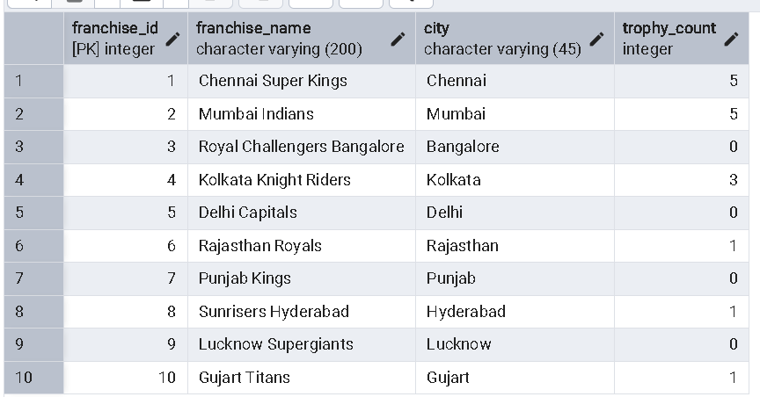

**Player table = It is used to stored information about player , its role and contract amount.**

**select * from player order by player_id;**

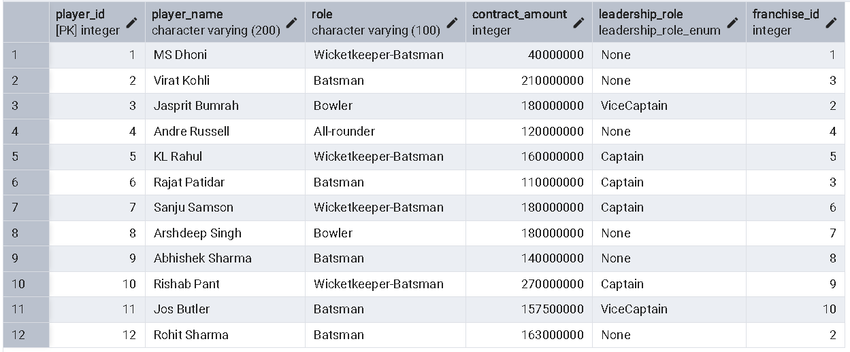

**Staff table = It is used to store info about supporting staff and their role in team.**

**select * from Supportingstaff order by staff_id;**

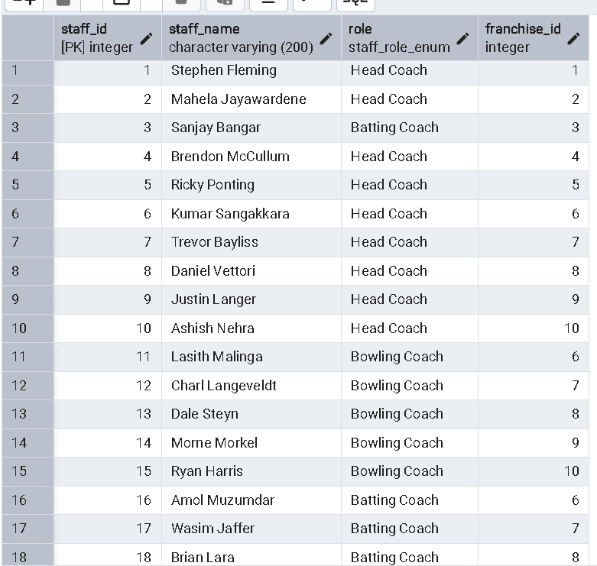

**Owner table = It is used to store information about their owner and owner group.**

**select * From Owner order by owner_id;**

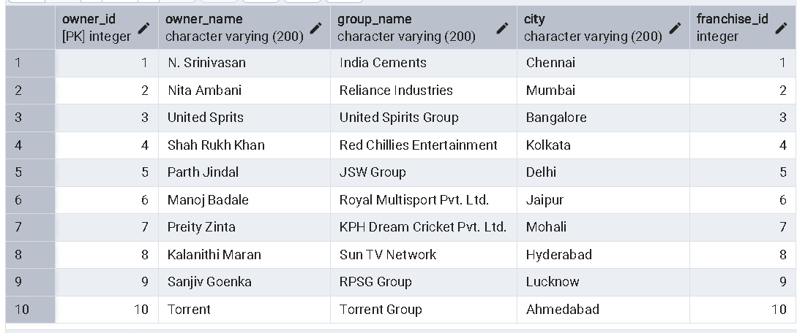

**Sponsor table = It is used to store info about sponsor of each franchise and their sponsorship amount for each franchise.**

**select * From sponsor order by sponsor_id;**

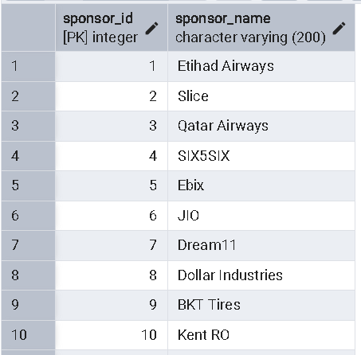

**select * from SponsorFranchise order by sponsor_id;**

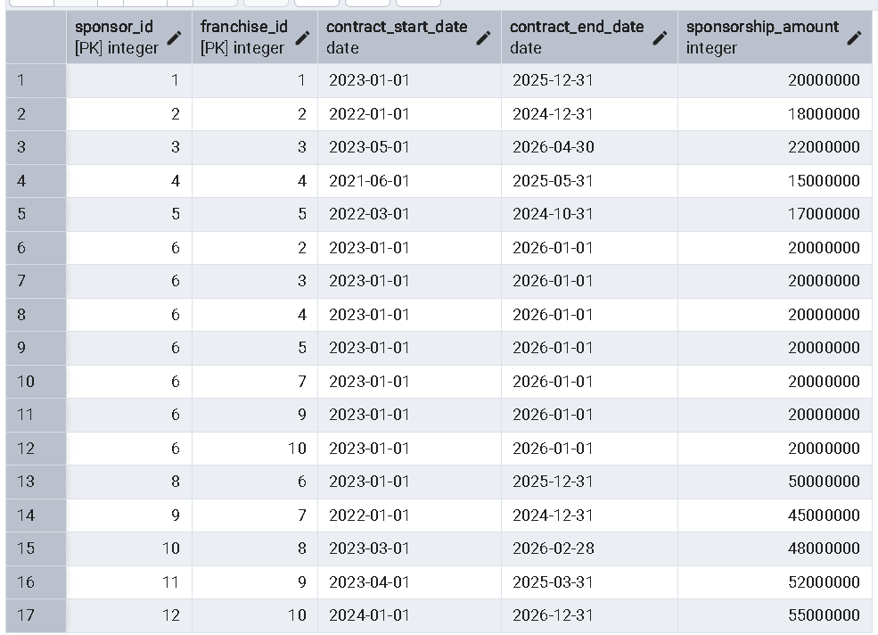

**Stadium table = It is used to store information about each stadium of particular franchises.**

**select * from Stadium order by stadium_id;**

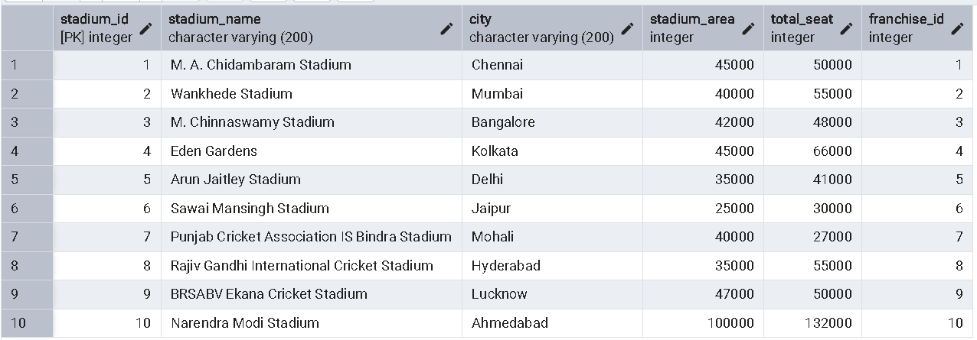

**Winner table = It is used to store info about Ipl winning team , runner up , man of match and player of tournament of that ipl year.**

**select * from Winner order by winner_id;**

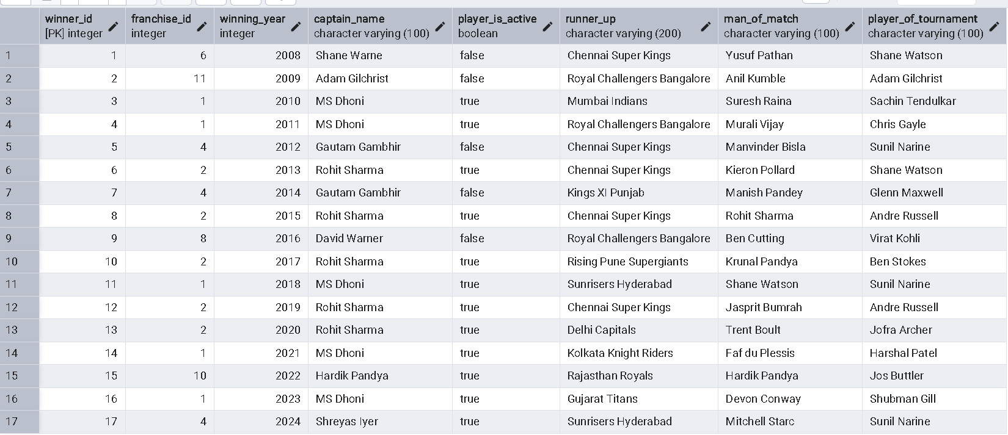

**//QUERIES:-**

**-- 1. Group players by their franchise id --**

**SELECT f.franchise_name,f.franchise_id, STRING_AGG(p.player_name , ' , ') AS players**

**FROM Franchise f**

**LEFT JOIN Player p ON f.franchise_id = p.franchise_id**

**GROUP BY f.franchise_name, f.franchise_id**

**ORDER BY FRANCHISE_id**

**limit 10;**

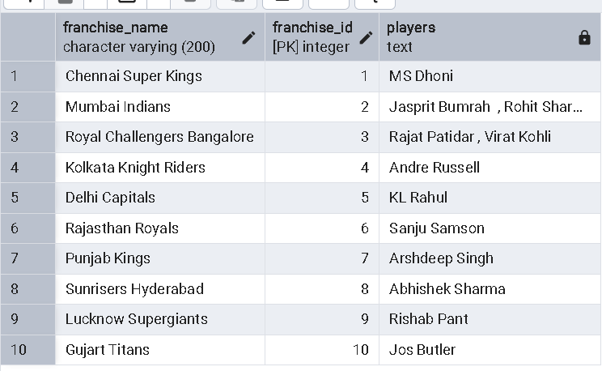

**-- 2. Total Trophies Won by Each Franchise--**

**SELECT franchise_name, trophy_count**

**FROM Franchise**

**ORDER BY trophy_count DESC;**

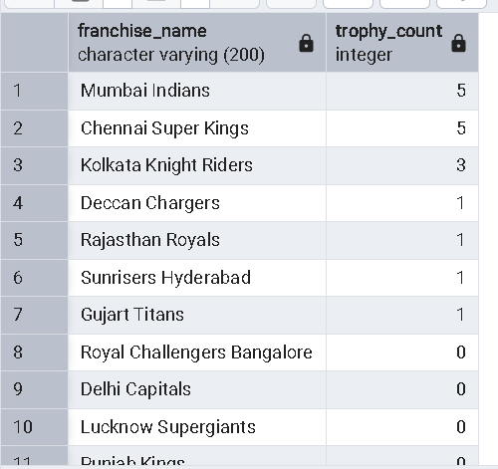

**--3. Total Seating Capacity Per City of Stadium--**

SELECT city, sum(total_seat) AS total_capacity

FROM Stadium

GROUP BY city

ORDER BY total_capacity DESC;

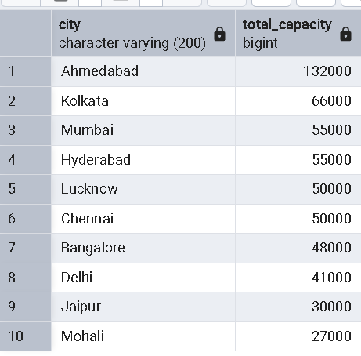

**--4. Total Players Owned by Each Franchise--**

SELECT f.franchise_name,f.franchise_id, COUNT(p.player_id) AS total_players

FROM Franchise f

LEFT JOIN Player p ON f.franchise_id = p.franchise_id

GROUP BY f.franchise_name,f.franchise_id

ORDER BY franchise_id

limit 10;

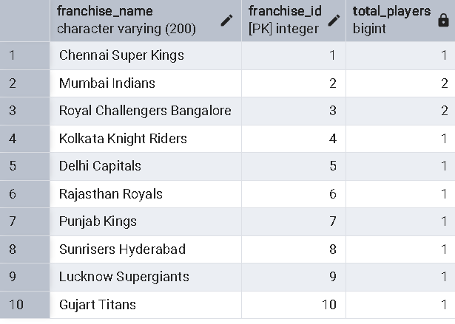

**--5. Total Owner of each Franchise--**

SELECT f.franchise_name,f.franchise_id, COUNT(o.owner_id) AS total_owners

FROM Franchise f

LEFT JOIN Owner o ON f.franchise_id = o.franchise_id

GROUP BY f.franchise_name,f.franchise_id

ORDER BY f.franchise_id

limit 10;

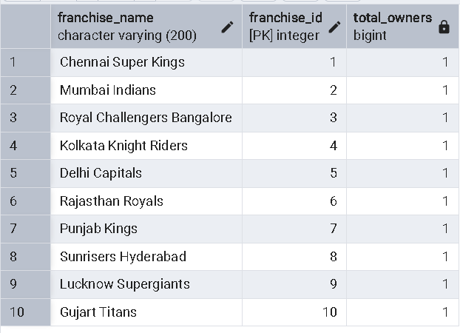

**--6. Total amount spend by each franchise--**

select f.franchise_name,f.franchise_id, sum(p.contract_amount) as total_amount

from franchise f

join player p on f.franchise_id = p.franchise_id

group by f.franchise_name,f.franchise_id

order by franchise_id

limit 10;

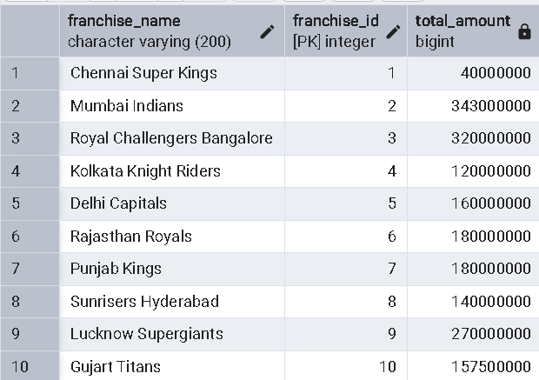

**--7. Find the Most Valuable Players Based on Contract Amount--**

SELECT f.franchise_name, p.player_name, p.contract_amount

FROM Franchise f

JOIN Player p ON f.franchise_id = p.franchise_id

ORDER BY p.contract_amount DESC

LIMIT 1;

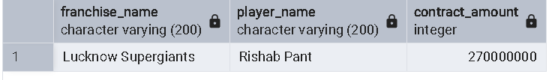

**-- Find all Players Who Are Vice-Captains--**

SELECT f.franchise_name, p.player_name as vicecaptain

FROM Franchise f

JOIN Player p ON f.franchise_id = p.franchise_id

WHERE p.leadership_role = 'ViceCaptain'

order by franchise_name;

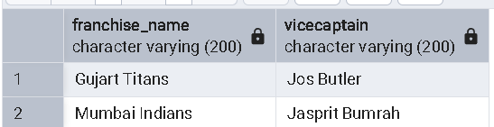

**--8. Find All Supporting Staff of Each Franchise--**

SELECT f.franchise_name,f.franchise_id, ARRAY_AGG(s.staff_name) AS staff_members

FROM Franchise f

LEFT JOIN SupportingStaff s ON f.franchise_id = s.franchise_id

GROUP BY f.franchise_name,f.franchise_id

order by franchise_id

limit 10;

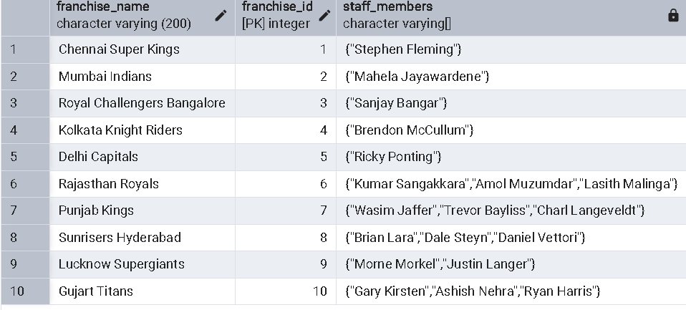

**--9. Find Stadiums Linked to Each Franchise--**

SELECT f.franchise_name,f.franchise_id, ARRAY_AGG(s.stadium_name) AS stadiums

FROM Franchise f

LEFT JOIN Stadium s ON f.franchise_id = s.franchise_id

GROUP BY f.franchise_id,f.franchise_name

order by f.franchise_id;

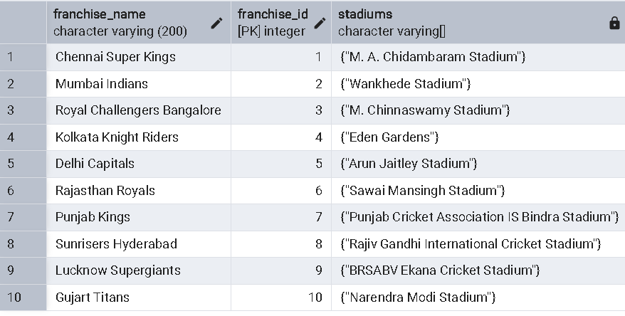

**--10. Find All Owners Linked to Each Franchise--**

SELECT f.franchise_name,f.franchise_id, ARRAY_AGG(o.owner_name) AS owners

FROM Franchise f

LEFT JOIN Owner o ON f.franchise_id = o.franchise_id

GROUP BY f.franchise_name,f.franchise_id

order by franchise_id;

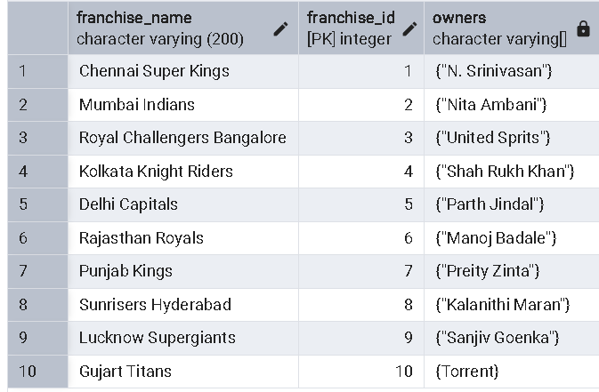

**--11. Finding sponsor for each franchise--**

SELECT f.franchise_name, s.sponsor_name, sf.contract_start_date, sf.contract_end_date, sf.sponsorship_amount

FROM SponsorFranchise sf

JOIN Franchise f ON sf.franchise_id = f.franchise_id

JOIN Sponsor s ON sf.sponsor_id = s.sponsor_id

ORDER BY f.franchise_name;

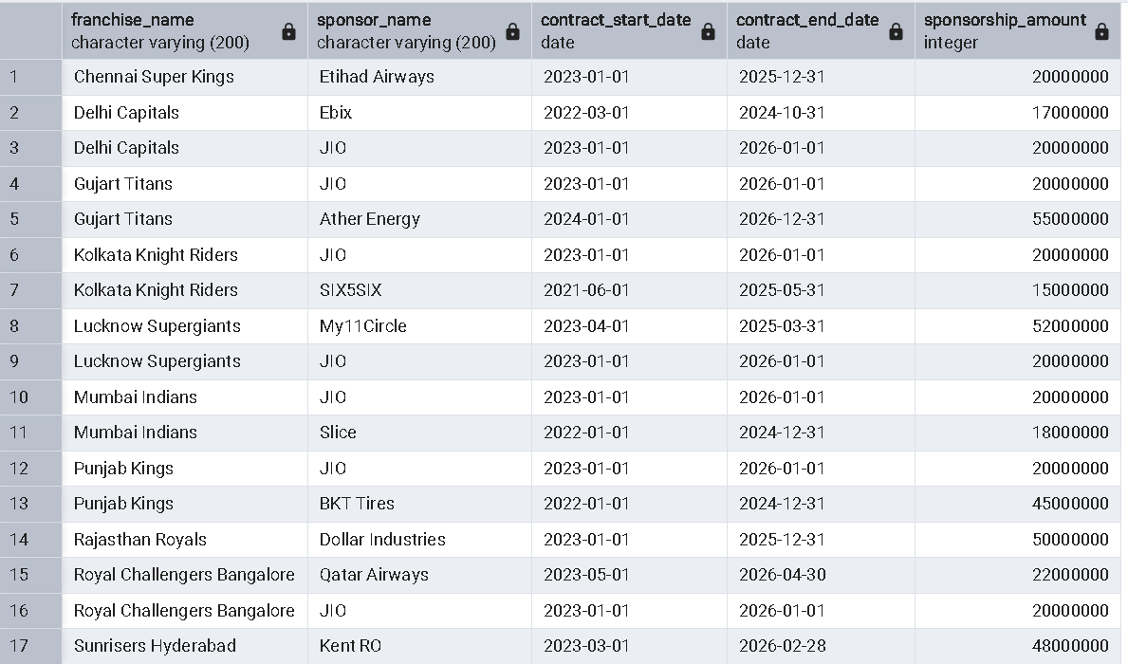

**--12. Finding all batsman in each team**

SELECT f.franchise_name,

ARRAY_AGG(p.player_name) AS batsmen

FROM Franchise f

JOIN Player p ON f.franchise_id = p.franchise_id

WHERE p.role = 'Batsman'

GROUP BY f.franchise_name;

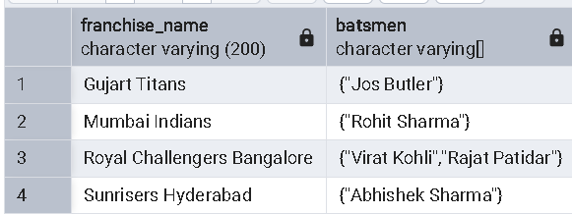

**--13. Finding all bowler in each team**

SELECT f.franchise_name,

ARRAY_AGG(p.player_name) AS bowler

FROM Franchise f

JOIN Player p ON f.franchise_id = p.franchise_id

WHERE p.role = 'Bowler'

GROUP BY f.franchise_name;

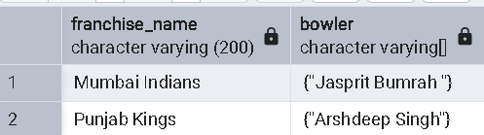

**--14. Finding all wickerkeeper in each team**

SELECT f.franchise_name,

ARRAY_AGG(p.player_name) AS wicketkeeper

FROM Franchise f

JOIN Player p ON f.franchise_id = p.franchise_id

WHERE p.role = 'Wicketkeeper-Batsman'

GROUP BY f.franchise_name;

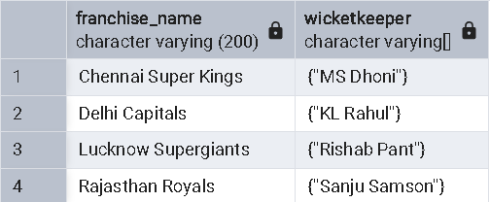

**--15. Find all allrounder in each team--**

SELECT f.franchise_name,

ARRAY_AGG(p.player_name) AS allrounder

FROM Franchise f

JOIN Player p ON f.franchise_id = p.franchise_id

WHERE p.role = 'All-rounder'

GROUP BY f.franchise_name;

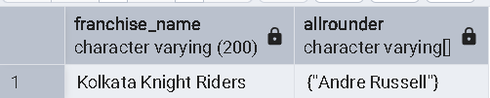

**--16. Finding teams that won ipl more than two time--**

select * from winner;

SELECT f.franchise_name,COUNT(w.winner_id) AS total_wins

FROM Winner w

JOIN Franchise f ON w.franchise_id = f.franchise_id

GROUP BY f.franchise_name

HAVING COUNT(w.winner_id) > 2

ORDER BY total_wins DESC;

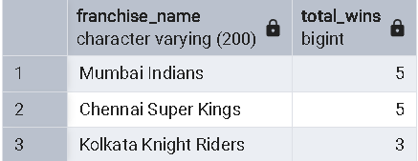

**--17. Finding all captain who have won most ipl titles--**

SELECT captain_name, COUNT(winner_id) AS total_wins

FROM Winner

GROUP BY captain_name

ORDER BY total_wins DESC

Limit 2;

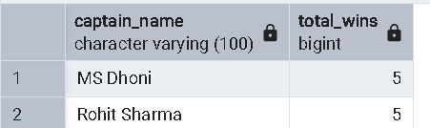

**--18. Finding all captain who is not playing ipl--**

Select distinct Captain_name as inactive_player

from winner

where player_is_active = False

order by captain_name;

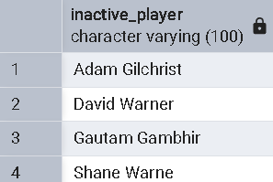

**--19. Finding all captain who is still playing ipl--**

Select distinct (captain_name) as active_player

from winner

where player_is_active = true

order by captain_name;

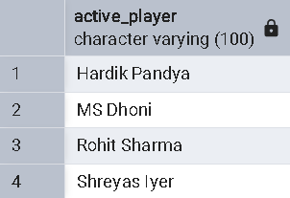

**--20. Total IPL title wins by each franchise--**

Select f.franchise_name , count(w.winner_id) as total_wins

from winner w

join Franchise f on w.franchise_id = f.franchise_id

group by f.franchise_name

order by total_wins desc;

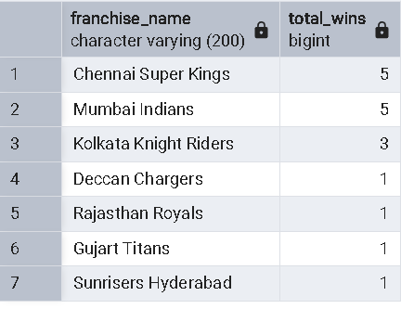

**--21. Stored procedure for inserting player--**

create or replace procedure inserting_player(

p_player_name varchar,

p_role varchar,

p_contract_amount int,

p_leadership_role leadership_role_enum,

p_franchise_id int)

language plpgsql

AS $$

begin

insert into player(player_name,role,contract_amount,leadership_role,franchise_id)

values(p_player_name,p_role,p_contract_amount,p_leadership_role,p_franchise_id);

end;

$$;

select * from player;

call inserting_player('Rohit Sharma','Batsman',163000000,'None',2);

**--21. Stored procedure for inserting stadium--**

create or replace procedure inserting_stadium(

p_stadium_name varchar,

p_city varchar,

p_stadium_area int,

p_total_seat int,

p_franchise_id int)

language plpgsql

AS $$

begin

insert into stadium(stadium_name,city,stadium_area,total_seat,franchise_id)

values(p_stadium_name,p_city,p_stadium_area,p_total_seat,p_franchise_id);

end;

$$;

call inserting_stadium();

**--22.Stored procedure for updating player--**

CREATE OR REPLACE PROCEDURE updating_player(

p_player_id INT,

p_player_name VARCHAR DEFAULT NULL,

p_role VARCHAR DEFAULT NULL,

p_contract_amount INT DEFAULT NULL,

p_leadership_role leadership_role_enum DEFAULT NULL,

p_franchise_id INT DEFAULT NULL

)

LANGUAGE plpgsql

AS $$

BEGIN

UPDATE player

SET

player_name = COALESCE(p_player_name, player_name),

role = COALESCE(p_role, role),

contract_amount = COALESCE(p_contract_amount, contract_amount),

leadership_role = COALESCE(p_leadership_role, leadership_role),

franchise_id = COALESCE(p_franchise_id, franchise_id)

WHERE player_id = p_player_id;

END;

$$;

**--23. Updating stadium using stored procedure--**

CREATE OR REPLACE PROCEDURE update_stadium(

p_stadium_id INT,

p_stadium_name VARCHAR DEFAULT NULL,

p_city VARCHAR DEFAULT NULL,

p_stadium_area INT DEFAULT NULL,

p_total_seat INT DEFAULT NULL,

p_franchise_id INT DEFAULT NULL

)

LANGUAGE plpgsql

AS $$

BEGIN

UPDATE Stadium

SET

stadium_name = COALESCE(p_stadium_name, stadium_name),

city = COALESCE(p_city, city),

stadium_area = COALESCE(p_stadium_area, stadium_area),

total_seat = COALESCE(p_total_seat, total_seat),

franchise_id = COALESCE(p_franchise_id, franchise_id)

WHERE stadium_id = p_stadium_id;

END;

$$;

CALL updating_player(12,null,null,null,'Captain'::leadership_role_enum,null);

Call updating_player(12,null,null,null,'None',null);

**--24. Stored procedure for deleting player--**

create or replace procedure deleting_player(p_player_id int)

language plpgsql

as $$

begin

delete from player where player_id = p_player_id;

end;

$$;

select * from player;

select * from stadium;

call deleting_player(12);

**--25. Deleting stadium using stored procedure--**

CREATE OR REPLACE PROCEDURE delete_stadium(p_stadium_id INT)

LANGUAGE plpgsql

AS $$

BEGIN

DELETE FROM Stadium WHERE stadium_id = p_stadium_id;

END;

$$;

**--26. function for getting trophy count for each franchise--**

create or replace function trophy_count(f_franchise_id int)

returns table(franchise_id int,franchise_name varchar,city varchar, trophy_count int)

language plpgsql

As $$

Begin

Return query

Select f.franchise_id,f.franchise_name,f.city,f.trophy_count from franchise f where f.franchise_id = f_franchise_id;

End;

$$;

select * from trophy_count(1);

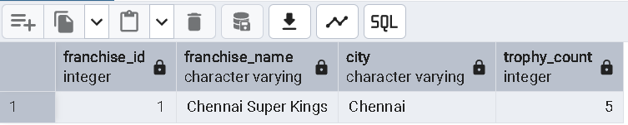

**--27. Stored procedure for getting trophies for all franchise:-**

CREATE OR REPLACE PROCEDURE get_franchises_by_trophies()

LANGUAGE plpgsql

AS $$

BEGIN

-- Fetch franchise name and trophy count in descending order

EXECUTE 'SELECT franchise_name, trophy_count FROM Franchise ORDER BY trophy_count DESC';

END;

$$;

**--28. function for getting captain for each franchise--**

CREATE OR REPLACE FUNCTION get_captains_for_each_franchise()

RETURNS TABLE (franchise_id INT, franchise_name VARCHAR, captain_name VARCHAR)

LANGUAGE plpgsql

AS $$

BEGIN

RETURN QUERY

SELECT

f.franchise_id,

f.franchise_name,

p.player_name AS captain_name

FROM Franchise f

JOIN Player p ON f.franchise_id = p.franchise_id

WHERE p.leadership_role = 'Captain'

ORDER BY f.franchise_id;

END;

$$;

select * from get_captains_for_each_franchise();

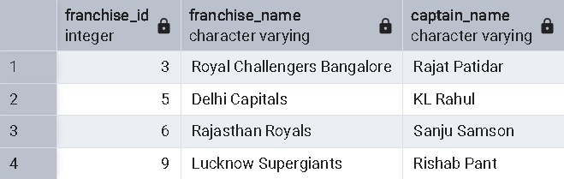

**29. Stored Function to Get Total Income for Each Franchise**

CREATE OR REPLACE FUNCTION get_total_income_for_each_franchise()

RETURNS TABLE (franchise_id INT, franchise_name VARCHAR, total_income BIGINT)

LANGUAGE plpgsql

AS $$

BEGIN

RETURN QUERY

SELECT

f.franchise_id,

f.franchise_name,

COALESCE(SUM(sf.sponsorship_amount), 0) AS total_income

FROM Franchise f

LEFT JOIN SponsorFranchise sf ON f.franchise_id = sf.franchise_id

GROUP BY f.franchise_id, f.franchise_name

ORDER BY total_income DESC;

END;

$$;

SELECT * FROM get_total_income_for_each_franchise();

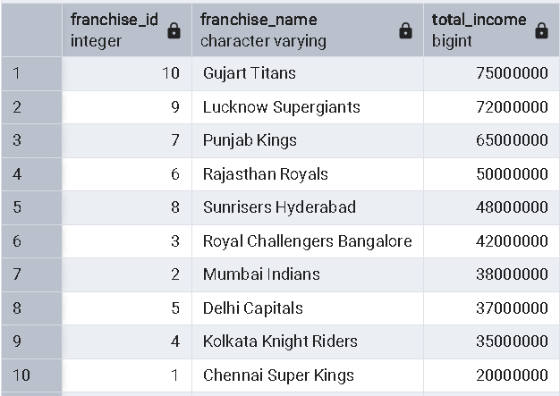

--**30. Function for total people in each franchise—**

**CREATE OR REPLACE FUNCTION get_total_people_in_franchise()**

**RETURNS TABLE (**

**franchise_id INT,**

**franchise_name VARCHAR,**

**total_players INT,**

**total_staff INT,**

**total_people INT**

**)**

**LANGUAGE plpgsql**

**AS $$**

**BEGIN**

**RETURN QUERY**

**SELECT**

**f.franchise_id,**

**f.franchise_name,**

**COALESCE(CAST(COUNT(DISTINCT p.player_id) AS INT), 0) AS total_players,**

**COALESCE(CAST(COUNT(DISTINCT s.staff_id) AS INT), 0) AS total_staff,**

**COALESCE(CAST(COUNT(DISTINCT p.player_id) AS INT), 0) + COALESCE(CAST(COUNT(DISTINCT s.staff_id) AS INT), 0) AS total_people**

**FROM Franchise f**

**LEFT JOIN Player p ON f.franchise_id = p.franchise_id**

**LEFT JOIN SupportingStaff s ON f.franchise_id = s.franchise_id**

**GROUP BY f.franchise_id, f.franchise_name**

**ORDER BY total_people DESC;**

**END;**

**$$;**

**SELECT * FROM get_total_people_in_franchise();**

